**PRACTICAL NO.3**

**Perform the data classification using classification algorithm using R/Python.**

**Code:**

> Hairfall<-c(12,13,14,17,15,18,12,13,14,17,19,18)

> Hairfall

[1] 12 13 14 17 15 18 12 13 14 17 19 18

> Hairfall.timeseries<-ts(Hairfall,start=c(2024,4),frequency=12)

> Hairfall.timeseries

Jan Feb Mar Apr May Jun Jul Aug Sep Oct Nov Dec

2024 12 13 14 17 15 18 12 13 14

2025 17 19 18

> plot(Hairfall.timeseries)

>

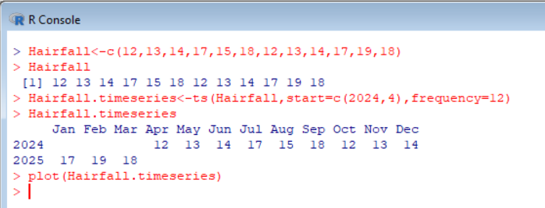

**Output:**

